**Manuals for ‘Manage Forms Emails’**

**Brief of the ‘Manage Forms Emails’ –** This is the page where we manage various forms mail address.

**1. How to manage forms emails-.**

Steps:

1. Login to the site and go to ‘Masters’ tab and click on ‘Manage Forms Emails’.
2. On ‘Manage Forms Emails’ page the listing of email ids with respective forms.
3. On this page we can edit the existing records.

1.

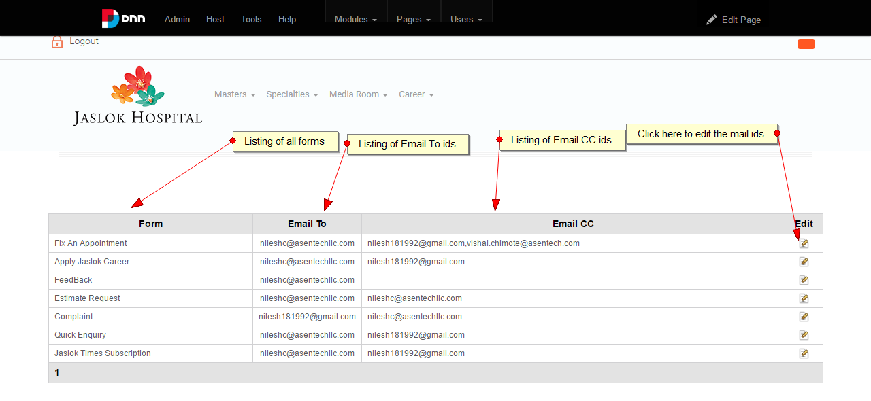

2.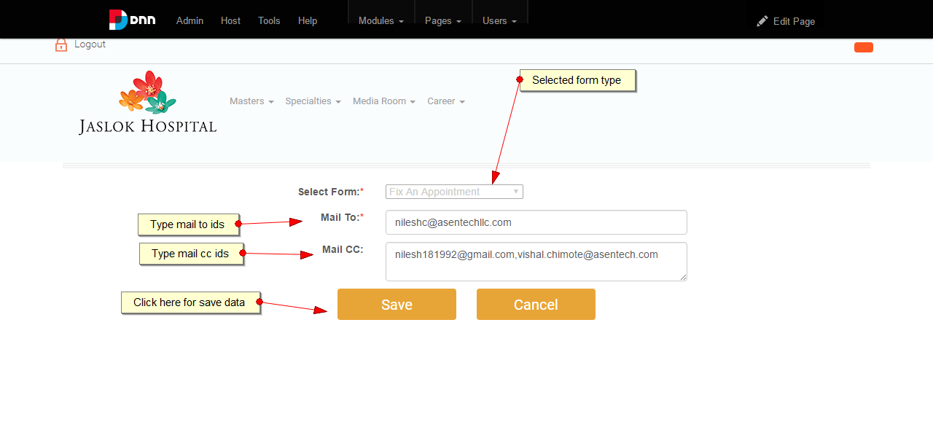

3.

